# 加载spring.factories流程

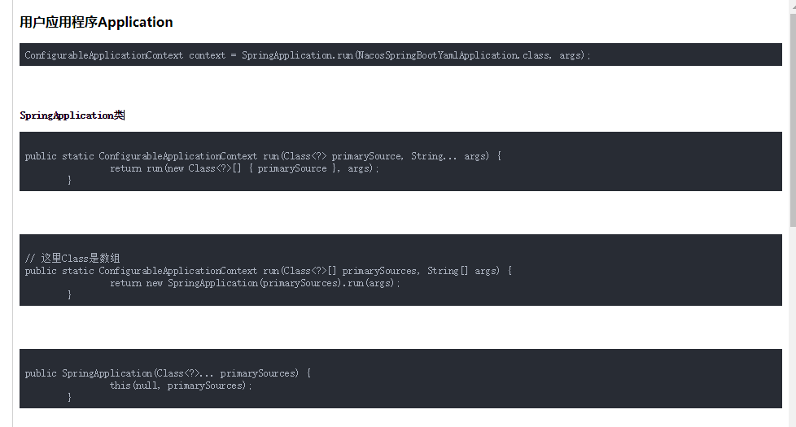

## SpringApplication构造函数

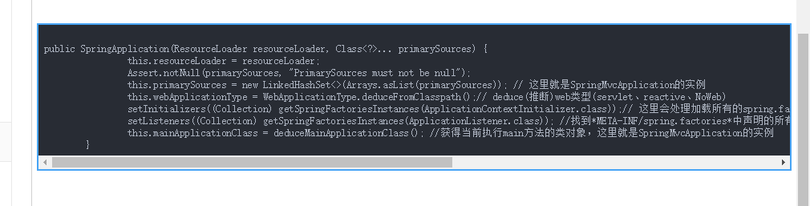

## loadSpringFactories

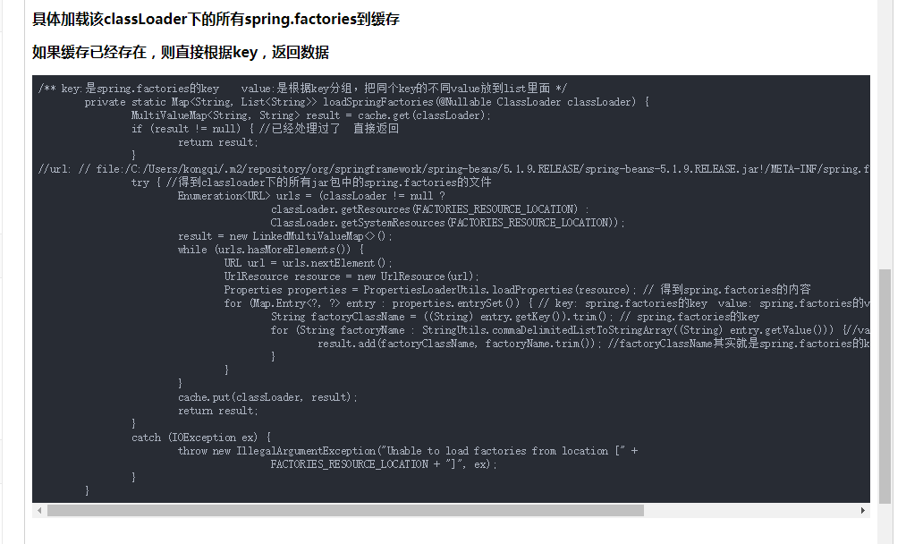

## 流程图

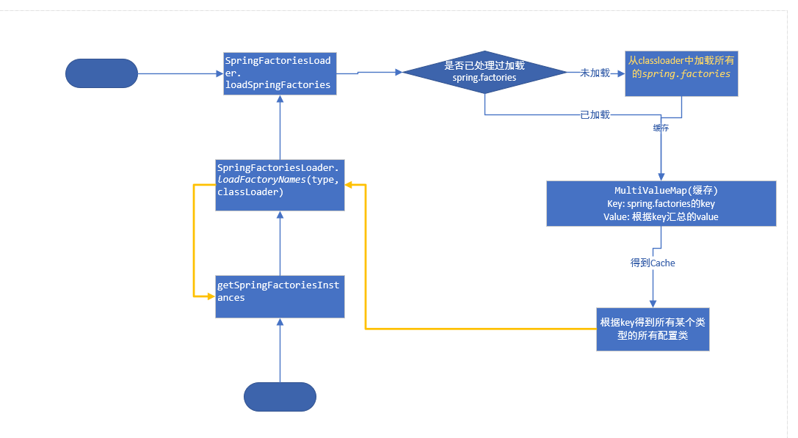

# 获取配置文件

## ConfigFileApplicationListener

### 接口 EnvironmentPostProcessor

public class ConfigFileApplicationListener implements EnvironmentPostProcessor, SmartApplicationListener, Ordered {

}

### jar包

springboot.jar

### spring.factories文件

# Application Listeners  
org.springframework.context.ApplicationListener=\  
org.springframework.boot.ClearCachesApplicationListener,\  
org.springframework.boot.builder.ParentContextCloserApplicationListener,\  
org.springframework.boot.context.FileEncodingApplicationListener,\  
org.springframework.boot.context.config.AnsiOutputApplicationListener,\  
org.springframework.boot.context.config.ConfigFileApplicationListener,\  
org.springframework.boot.context.config.DelegatingApplicationListener,\  
org.springframework.boot.context.logging.ClasspathLoggingApplicationListener,\  
org.springframework.boot.context.logging.LoggingApplicationListener,\  
org.springframework.boot.liquibase.LiquibaseServiceLocatorApplicationListener

### 主要属性

*/**  
 * The "config name" property name.  
 */*public static final String *CONFIG_NAME_PROPERTY* = "spring.config.name";  
  
*/**  
 * The "config location" property name.  
 */*public static final String *CONFIG_LOCATION_PROPERTY* = "spring.config.location";  
  
*/**  
 * The "config additional location" property name.  
 */*public static final String *CONFIG_ADDITIONAL_LOCATION_PROPERTY* = "spring.config.additional-location";

### 默认目录优先级

*\* <ul>  
* <li>file:./config/:</li>  
* <li>file:./</li>  
* <li>classpath:config/</li>  
* <li>classpath:</li>  
* </ul>*

位置越高，优先级越高，高的覆盖低的

### 根据active

*Additional files will also be loaded based on active profiles. For example if a 'web'  
* profile is active 'application-web.properties' and 'application-web.yml' will be  
* considered.*

### 指定具体文件名和目录

*spring.config.name // 文件名*

*spring.config.location //目录*

### 主要类

#### ResourceLoader

##### PropertiesPropertySourceLoader

处理application.propertiest application.xml

##### YamlPropertySourceLoader

处理application.yml application.yaml

#### PropertySourcesPlaceholdersResolver

### 主要图

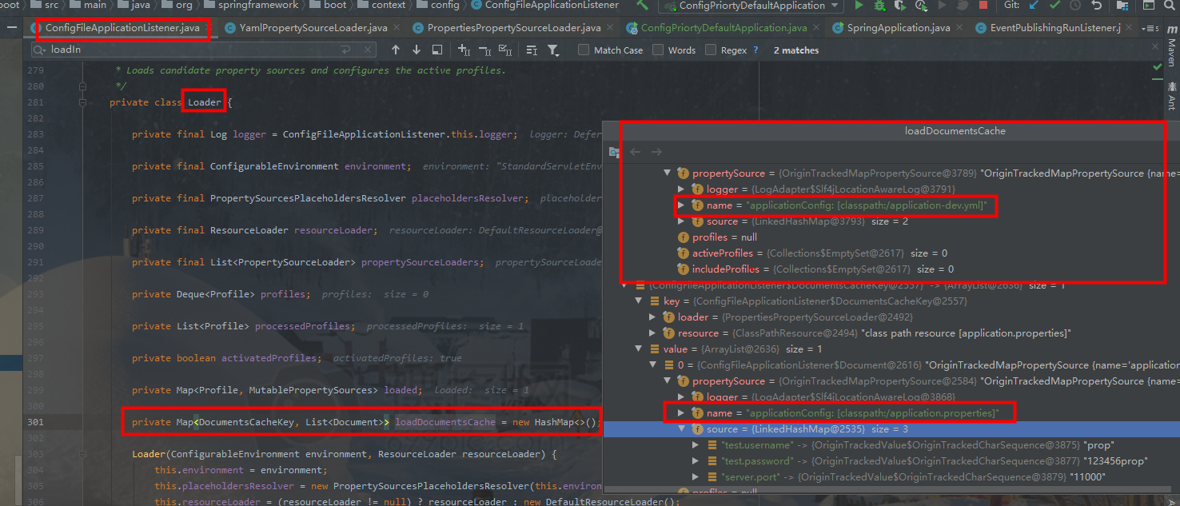

#### application优先级顺序

##### program argument参数

commandLineArgs

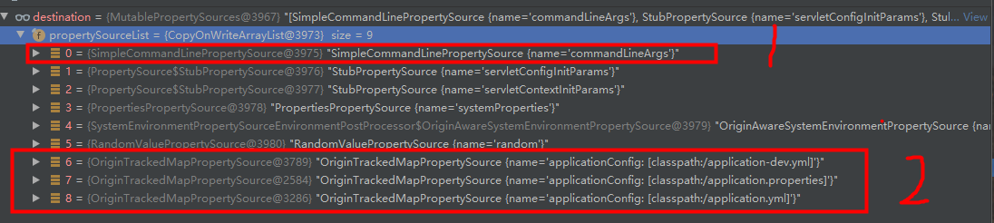

越上面的优先级越高

1: program argument参数

##### vm options

systemProperties

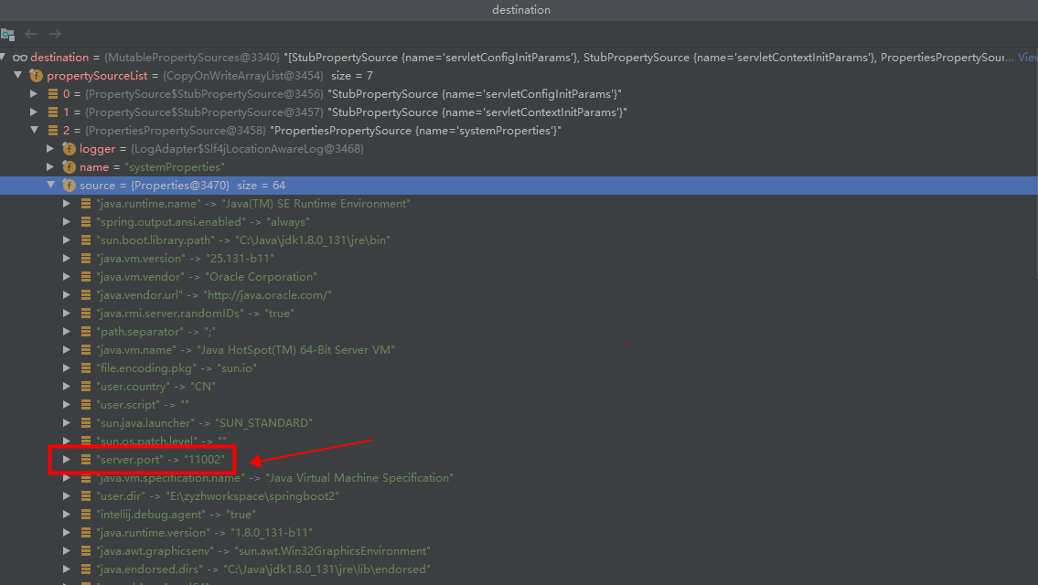

##### 操作系统参数

systemEnvironment

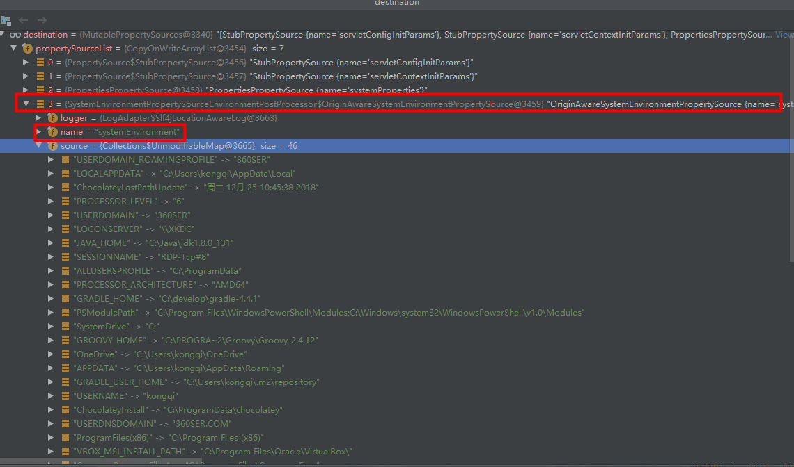

##### 具体的application配置文件



##### 非default的spring.profiles.active

比如application-prod.yml 优先级高于所有的application.properties(yml)

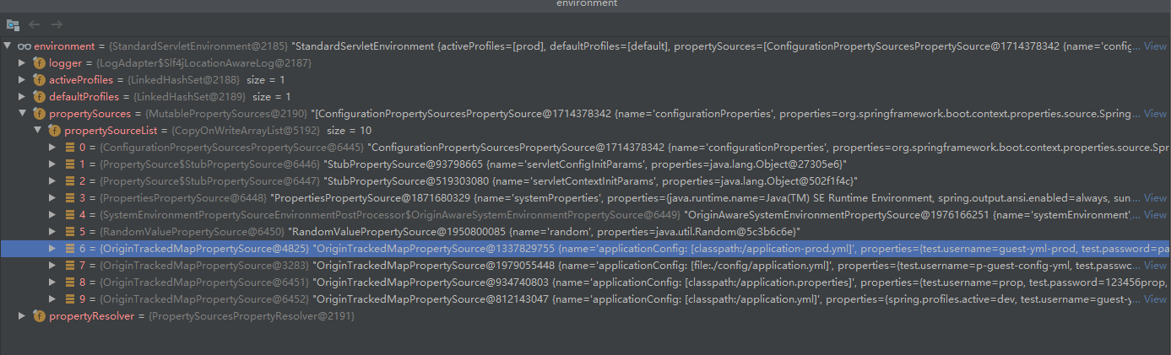

### 主要流程

触发onApplicationEvent事件，最终调用EnvironmentPostProcessor 接口的postProcessEnvironment函数

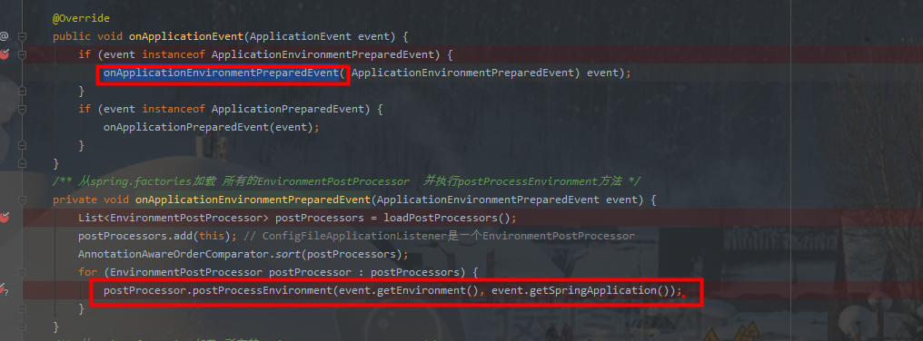

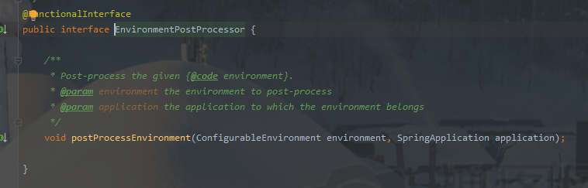

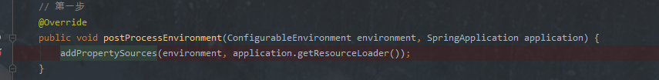

调用addPropertySources

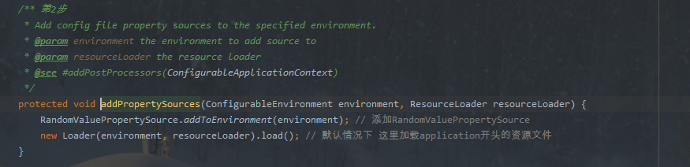

#### Loader

##### 构造函数

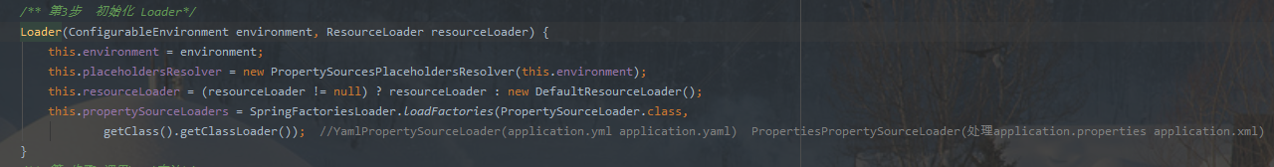

##### load方法

重点关注流程:

在initializeProfiles 函数中，profiles先添加null 然后再添加default的值，profiles.size=2

1. 先在所有的目录下加载application.properties、application.xml、application.yml、application.yaml文件，每个文件1个PropertySource，在这些文件中，如果配置了spring.profiles.active，会得到第一个配置的profile的值(这个profile会被添加到profiles的列表中去)，其余配置文件的配置的profile会被忽略(不会添加到profiles列表)
2. 第一个profile=null，处理完成后，遍历下一个profile（如果有配置过的profile，则这个时候已经把defalut删除了，如果没配置过profile，则这个时候是default），然后再重新加载1遍所有目录的(application)配置文件

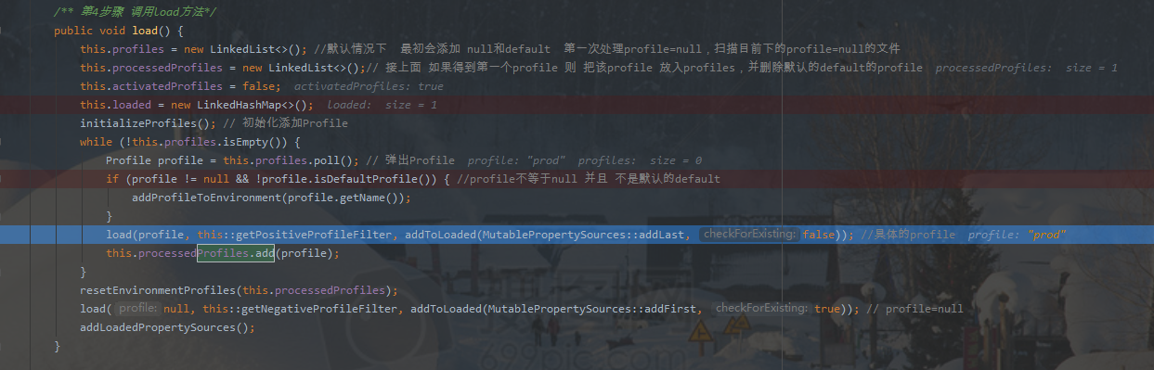

解析配置文件的时候，如果解析到spring.profile.active

1. 先判断activatedProfiles是否为true,

activatedProfiles=true，代表有么有处理过第一个spring.profile.active，则直接忽略剩余所有配制文件中的spring.profile.active属性

1. 如果activatedProfiles=false，则把第一个profile，添加到profiles列表中去，并把activatedProfiles标志位设置为true，并删除默认的defalut的profile

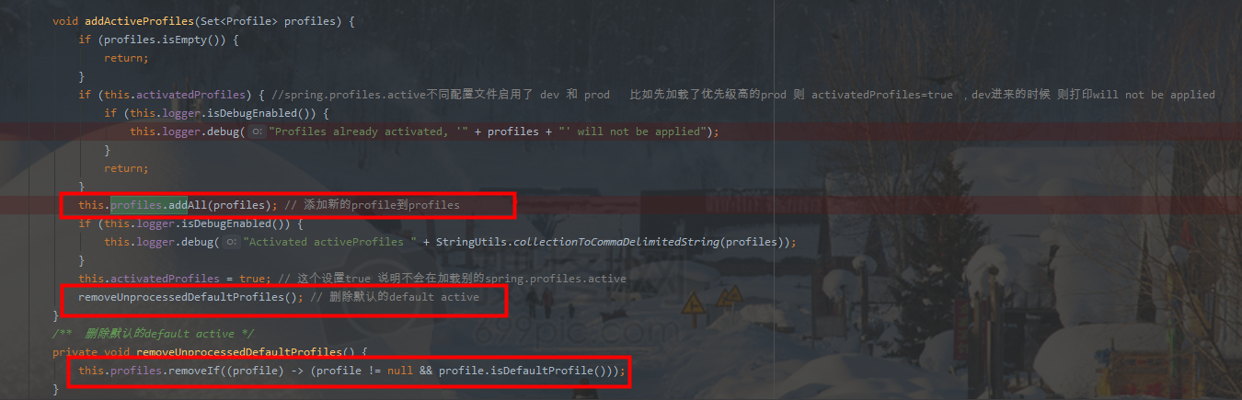

### 多profile

file:./config/application.yml 配置了spring.profiles.active=prod,test

classpath:/application.yml配置了

spring.profiles.active=dev (忽略)

spring.profiles.include=mysql,mongodb

#### 按顺序添加PropertySource

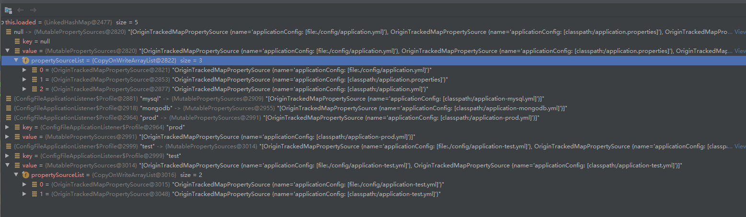

#### 反转

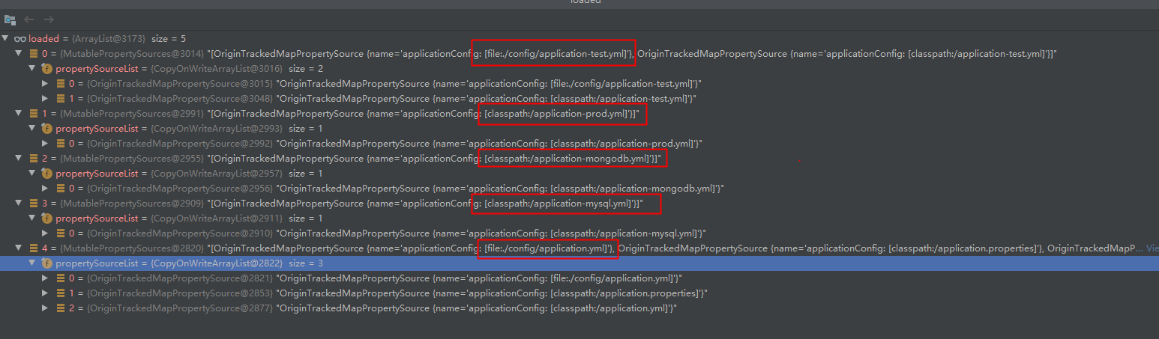

### 多profile 多include

Spring.profiles.active(配置多个，只会用第一个)

Spring.profile.include(多个会合并)

这个是解析配置文件顺序，使用值的时候，最终会反转

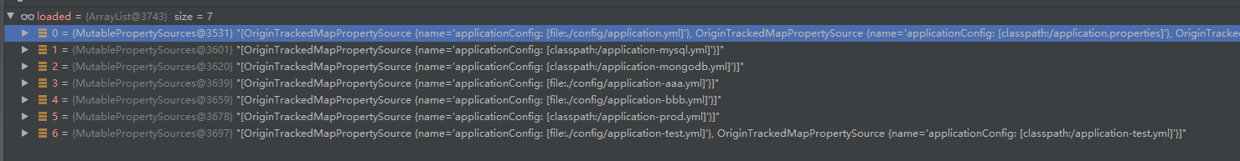

#### 最终使用反转的

spring.profiles.active 使用第一个解析到的profile，在最上面，如果有多个值，优先级从右到左

spring.profiles.include 第1个解析到的profile在上面，如果有多个值，优先级从右到左

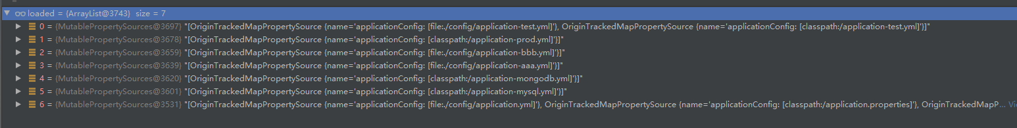

### 注意

spring.profiles.active 只会要第一个读取到的配置，其余配置都会被忽略

spring.profiles.include 会把所有读取到配置，汇总放到set里面(不同配置文件中，spring.profiles.include属性会叠加)

### 调试

processor.toString().indexOf("ConfigFile")>=0

### 加载application文件顺序

同个配置文件，就算加载多次，最后也只会有1份数据

2020-02-28 09:02:26.540 [main] INFO c.k.config.priorty.ConfigPriortyDefaultApplication-The following profiles are active: prod

2020-02-28 09:02:26.540 [main] DEBUG org.springframework.boot.SpringApplication-Loading source class com.kq.config.priorty.ConfigPriortyDefaultApplication

2020-02-28 09:02:26.763 [main] TRACE o.s.b.context.config.ConfigFileApplicationListener-Skipped missing config 'file:./config/application.properties' (file:./config/application.properties)

2020-02-28 09:02:26.764 [main] TRACE o.s.b.context.config.ConfigFileApplicationListener-Skipped missing config 'file:./config/application.xml' (file:./config/application.xml)

2020-02-28 09:02:26.764 [main] DEBUG o.s.b.context.config.ConfigFileApplicationListener-Activated activeProfiles prod

2020-02-28 09:02:26.764 [main] DEBUG o.s.b.context.config.ConfigFileApplicationListener-Loaded config file 'file:./config/application.yml' (file:./config/application.yml)

2020-02-28 09:02:26.764 [main] TRACE o.s.b.context.config.ConfigFileApplicationListener-Skipped missing config 'file:./config/application.yaml' (file:./config/application.yaml)

2020-02-28 09:02:26.765 [main] TRACE o.s.b.context.config.ConfigFileApplicationListener-Skipped missing config 'file:./application.properties' (file:./application.properties)

2020-02-28 09:02:26.765 [main] TRACE o.s.b.context.config.ConfigFileApplicationListener-Skipped missing config 'file:./application.xml' (file:./application.xml)

2020-02-28 09:02:26.765 [main] TRACE o.s.b.context.config.ConfigFileApplicationListener-Skipped missing config 'file:./application.yml' (file:./application.yml)

2020-02-28 09:02:26.765 [main] TRACE o.s.b.context.config.ConfigFileApplicationListener-Skipped missing config 'file:./application.yaml' (file:./application.yaml)

2020-02-28 09:02:26.765 [main] TRACE o.s.b.context.config.ConfigFileApplicationListener-Skipped missing config classpath:/config/application.properties

2020-02-28 09:02:26.765 [main] TRACE o.s.b.context.config.ConfigFileApplicationListener-Skipped missing config classpath:/config/application.xml

2020-02-28 09:02:26.765 [main] TRACE o.s.b.context.config.ConfigFileApplicationListener-Skipped missing config classpath:/config/application.yml

2020-02-28 09:02:26.765 [main] TRACE o.s.b.context.config.ConfigFileApplicationListener-Skipped missing config classpath:/config/application.yaml

2020-02-28 09:02:26.766 [main] DEBUG o.s.b.context.config.ConfigFileApplicationListener-Loaded config file 'file:/E:/zyzhworkspace/springboot2/config-priority/config-priority-default/target/classes/application.properties' (classpath:/application.properties)

2020-02-28 09:02:26.766 [main] TRACE o.s.b.context.config.ConfigFileApplicationListener-Skipped missing config classpath:/application.xml

2020-02-28 09:02:26.766 [main] DEBUG o.s.b.context.config.ConfigFileApplicationListener-Profiles already activated, '[dev]' will not be applied

2020-02-28 09:02:26.766 [main] DEBUG o.s.b.context.config.ConfigFileApplicationListener-Loaded config file 'file:/E:/zyzhworkspace/springboot2/config-priority/config-priority-default/target/classes/application.yml' (classpath:/application.yml)

2020-02-28 09:02:26.766 [main] TRACE o.s.b.context.config.ConfigFileApplicationListener-Skipped missing config classpath:/application.yaml

2020-02-28 09:02:26.766 [main] TRACE o.s.b.context.config.ConfigFileApplicationListener-Skipped missing config 'file:./config/application-prod.properties' (file:./config/application-prod.properties) for profile prod

2020-02-28 09:02:26.766 [main] TRACE o.s.b.context.config.ConfigFileApplicationListener-Skipped missing config 'file:./config/application-prod.properties' (file:./config/application-prod.properties) for profile prod

2020-02-28 09:02:26.766 [main] TRACE o.s.b.context.config.ConfigFileApplicationListener-Skipped missing config 'file:./config/application.properties' (file:./config/application.properties) for profile prod

2020-02-28 09:02:26.766 [main] TRACE o.s.b.context.config.ConfigFileApplicationListener-Skipped missing config 'file:./config/application-prod.xml' (file:./config/application-prod.xml) for profile prod

2020-02-28 09:02:26.766 [main] TRACE o.s.b.context.config.ConfigFileApplicationListener-Skipped missing config 'file:./config/application-prod.xml' (file:./config/application-prod.xml) for profile prod

2020-02-28 09:02:26.766 [main] TRACE o.s.b.context.config.ConfigFileApplicationListener-Skipped missing config 'file:./config/application.xml' (file:./config/application.xml) for profile prod

2020-02-28 09:02:26.767 [main] TRACE o.s.b.context.config.ConfigFileApplicationListener-Skipped missing config 'file:./config/application-prod.yml' (file:./config/application-prod.yml) for profile prod

2020-02-28 09:02:26.767 [main] TRACE o.s.b.context.config.ConfigFileApplicationListener-Skipped missing config 'file:./config/application-prod.yml' (file:./config/application-prod.yml) for profile prod

2020-02-28 09:02:26.767 [main] TRACE o.s.b.context.config.ConfigFileApplicationListener-Skipped missing config 'file:./config/application-prod.yaml' (file:./config/application-prod.yaml) for profile prod

2020-02-28 09:02:26.767 [main] TRACE o.s.b.context.config.ConfigFileApplicationListener-Skipped missing config 'file:./config/application-prod.yaml' (file:./config/application-prod.yaml) for profile prod

2020-02-28 09:02:26.767 [main] TRACE o.s.b.context.config.ConfigFileApplicationListener-Skipped missing config 'file:./config/application.yaml' (file:./config/application.yaml) for profile prod

2020-02-28 09:02:26.767 [main] TRACE o.s.b.context.config.ConfigFileApplicationListener-Skipped missing config 'file:./application-prod.properties' (file:./application-prod.properties) for profile prod

2020-02-28 09:02:26.767 [main] TRACE o.s.b.context.config.ConfigFileApplicationListener-Skipped missing config 'file:./application-prod.properties' (file:./application-prod.properties) for profile prod

2020-02-28 09:02:26.767 [main] TRACE o.s.b.context.config.ConfigFileApplicationListener-Skipped missing config 'file:./application.properties' (file:./application.properties) for profile prod

2020-02-28 09:02:26.767 [main] TRACE o.s.b.context.config.ConfigFileApplicationListener-Skipped missing config 'file:./application-prod.xml' (file:./application-prod.xml) for profile prod

2020-02-28 09:02:26.768 [main] TRACE o.s.b.context.config.ConfigFileApplicationListener-Skipped missing config 'file:./application-prod.xml' (file:./application-prod.xml) for profile prod

2020-02-28 09:02:26.768 [main] TRACE o.s.b.context.config.ConfigFileApplicationListener-Skipped missing config 'file:./application.xml' (file:./application.xml) for profile prod

2020-02-28 09:02:26.768 [main] TRACE o.s.b.context.config.ConfigFileApplicationListener-Skipped missing config 'file:./application-prod.yml' (file:./application-prod.yml) for profile prod

2020-02-28 09:02:26.768 [main] TRACE o.s.b.context.config.ConfigFileApplicationListener-Skipped missing config 'file:./application-prod.yml' (file:./application-prod.yml) for profile prod

2020-02-28 09:02:26.768 [main] TRACE o.s.b.context.config.ConfigFileApplicationListener-Skipped missing config 'file:./application.yml' (file:./application.yml) for profile prod

2020-02-28 09:02:26.768 [main] TRACE o.s.b.context.config.ConfigFileApplicationListener-Skipped missing config 'file:./application-prod.yaml' (file:./application-prod.yaml) for profile prod

2020-02-28 09:02:26.768 [main] TRACE o.s.b.context.config.ConfigFileApplicationListener-Skipped missing config 'file:./application-prod.yaml' (file:./application-prod.yaml) for profile prod

2020-02-28 09:02:26.768 [main] TRACE o.s.b.context.config.ConfigFileApplicationListener-Skipped missing config 'file:./application.yaml' (file:./application.yaml) for profile prod

2020-02-28 09:02:26.768 [main] TRACE o.s.b.context.config.ConfigFileApplicationListener-Skipped missing config classpath:/config/application-prod.properties for profile prod

2020-02-28 09:02:26.768 [main] TRACE o.s.b.context.config.ConfigFileApplicationListener-Skipped missing config classpath:/config/application-prod.properties for profile prod

2020-02-28 09:02:26.768 [main] TRACE o.s.b.context.config.ConfigFileApplicationListener-Skipped missing config classpath:/config/application.properties for profile prod

2020-02-28 09:02:26.768 [main] TRACE o.s.b.context.config.ConfigFileApplicationListener-Skipped missing config classpath:/config/application-prod.xml for profile prod

2020-02-28 09:02:26.769 [main] TRACE o.s.b.context.config.ConfigFileApplicationListener-Skipped missing config classpath:/config/application-prod.xml for profile prod

2020-02-28 09:02:26.769 [main] TRACE o.s.b.context.config.ConfigFileApplicationListener-Skipped missing config classpath:/config/application.xml for profile prod

2020-02-28 09:02:26.769 [main] TRACE o.s.b.context.config.ConfigFileApplicationListener-Skipped missing config classpath:/config/application-prod.yml for profile prod

2020-02-28 09:02:26.769 [main] TRACE o.s.b.context.config.ConfigFileApplicationListener-Skipped missing config classpath:/config/application-prod.yml for profile prod

2020-02-28 09:02:26.769 [main] TRACE o.s.b.context.config.ConfigFileApplicationListener-Skipped missing config classpath:/config/application.yml for profile prod

2020-02-28 09:02:26.769 [main] TRACE o.s.b.context.config.ConfigFileApplicationListener-Skipped missing config classpath:/config/application-prod.yaml for profile prod

2020-02-28 09:02:26.769 [main] TRACE o.s.b.context.config.ConfigFileApplicationListener-Skipped missing config classpath:/config/application-prod.yaml for profile prod

2020-02-28 09:02:26.769 [main] TRACE o.s.b.context.config.ConfigFileApplicationListener-Skipped missing config classpath:/config/application.yaml for profile prod

2020-02-28 09:02:26.769 [main] TRACE o.s.b.context.config.ConfigFileApplicationListener-Skipped missing config classpath:/application-prod.properties for profile prod

2020-02-28 09:02:26.769 [main] TRACE o.s.b.context.config.ConfigFileApplicationListener-Skipped missing config classpath:/application-prod.properties for profile prod

2020-02-28 09:02:26.770 [main] TRACE o.s.b.context.config.ConfigFileApplicationListener-Skipped missing config classpath:/application-prod.xml for profile prod

2020-02-28 09:02:26.770 [main] TRACE o.s.b.context.config.ConfigFileApplicationListener-Skipped missing config classpath:/application-prod.xml for profile prod

2020-02-28 09:02:26.770 [main] TRACE o.s.b.context.config.ConfigFileApplicationListener-Skipped missing config classpath:/application.xml for profile prod

2020-02-28 09:02:26.771 [main] DEBUG o.s.b.context.config.ConfigFileApplicationListener-Loaded config file 'file:/E:/zyzhworkspace/springboot2/config-priority/config-priority-default/target/classes/application-prod.yml' (classpath:/application-prod.yml) for profile prod

2020-02-28 09:02:26.771 [main] TRACE o.s.b.context.config.ConfigFileApplicationListener-Skipped missing config classpath:/application-prod.yaml for profile prod

2020-02-28 09:02:26.771 [main] TRACE o.s.b.context.config.ConfigFileApplicationListener-Skipped missing config classpath:/application-prod.yaml for profile prod

2020-02-28 09:02:26.771 [main] TRACE o.s.b.context.config.ConfigFileApplicationListener-Skipped missing config classpath:/application.yaml for profile prod

2020-02-28 09:02:26.771 [main] TRACE o.s.b.context.config.ConfigFileApplicationListener-Skipped missing config 'file:./config/application.properties' (file:./config/application.properties)

2020-02-28 09:02:26.771 [main] TRACE o.s.b.context.config.ConfigFileApplicationListener-Skipped missing config 'file:./config/application.xml' (file:./config/application.xml)

2020-02-28 09:02:26.771 [main] TRACE o.s.b.context.config.ConfigFileApplicationListener-Skipped missing config 'file:./config/application.yaml' (file:./config/application.yaml)

2020-02-28 09:02:26.771 [main] TRACE o.s.b.context.config.ConfigFileApplicationListener-Skipped missing config 'file:./application.properties' (file:./application.properties)

2020-02-28 09:02:26.771 [main] TRACE o.s.b.context.config.ConfigFileApplicationListener-Skipped missing config 'file:./application.xml' (file:./application.xml)

2020-02-28 09:02:26.772 [main] TRACE o.s.b.context.config.ConfigFileApplicationListener-Skipped missing config 'file:./application.yml' (file:./application.yml)

2020-02-28 09:02:26.772 [main] TRACE o.s.b.context.config.ConfigFileApplicationListener-Skipped missing config 'file:./application.yaml' (file:./application.yaml)

2020-02-28 09:02:26.772 [main] TRACE o.s.b.context.config.ConfigFileApplicationListener-Skipped missing config classpath:/config/application.properties

2020-02-28 09:02:26.772 [main] TRACE o.s.b.context.config.ConfigFileApplicationListener-Skipped missing config classpath:/config/application.xml

2020-02-28 09:02:26.772 [main] TRACE o.s.b.context.config.ConfigFileApplicationListener-Skipped missing config classpath:/config/application.yml

2020-02-28 09:02:26.772 [main] TRACE o.s.b.context.config.ConfigFileApplicationListener-Skipped missing config classpath:/config/application.yaml

2020-02-28 09:02:26.772 [main] TRACE o.s.b.context.config.ConfigFileApplicationListener-Skipped missing config classpath:/application.xml

2020-02-28 09:02:26.772 [main] TRACE o.s.b.context.config.ConfigFileApplicationListener-Skipped missing config classpath:/application.yaml

# Event

## SpringApplicationEvent

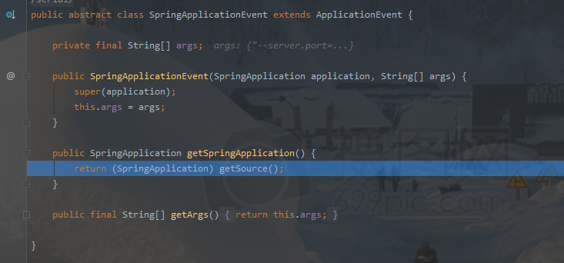

具体的applicaion文件

# StandardServletEnvironment

## 类

public class StandardServletEnvironment extends StandardEnvironment implements ConfigurableWebEnvironment {}

## 初始化

SpringApplication

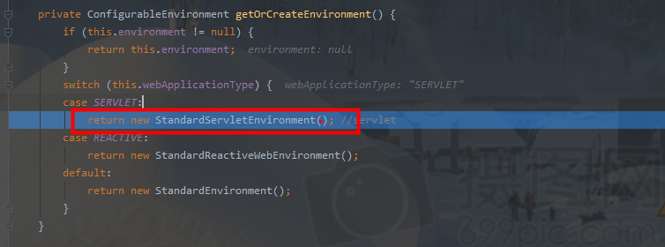

## 添加servletConfigInitParams、servletContextInitParams参数

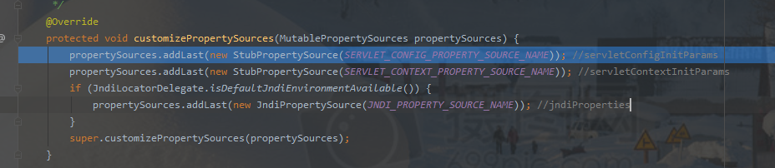

## 添加系统参数、环境变量PropertySource

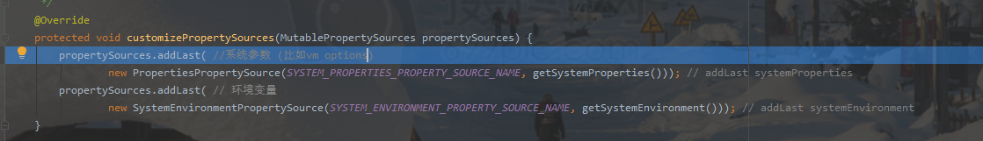

## uml时序图

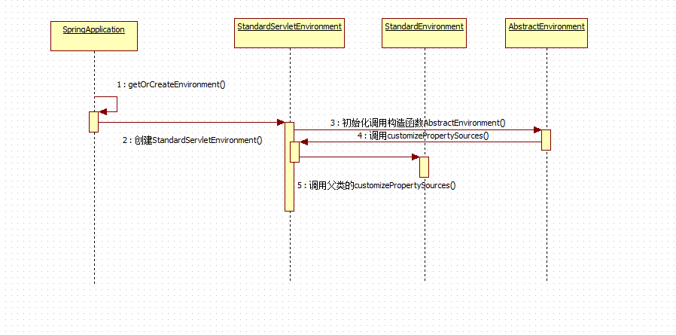

# RandomValuePropertySource

${random.uuid} ${random.int}

# @Value注入

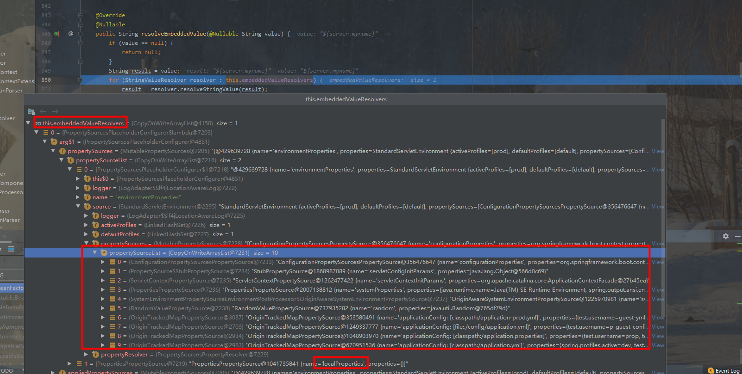

## ContextAnnotationAutowireCandidateResolver

## PropertySourcesPlaceholderConfigurer

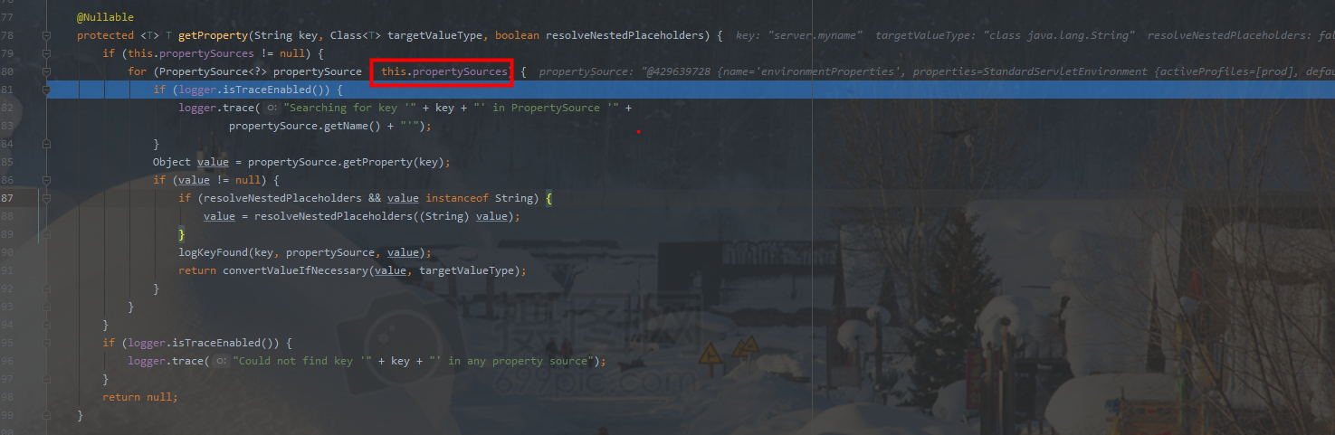

循环propertySources，如果有值，则立即返回

# BeanPostProcessor

## 方法

### bean初始化前执行

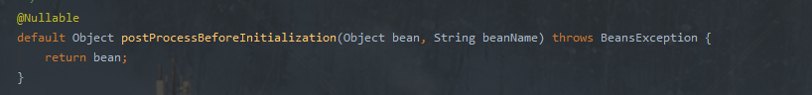

### bean初始化后执行

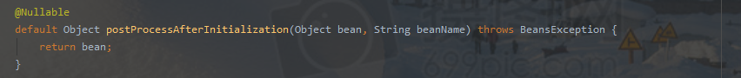

## AutowiredAnnotationBeanPostProcessor

@Autowired 默认实现类

## InstantiationAwareBeanPostProcessor



### 方法

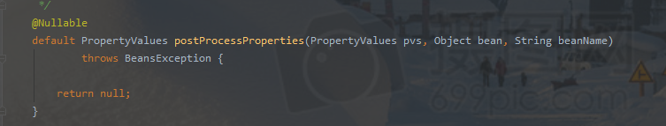

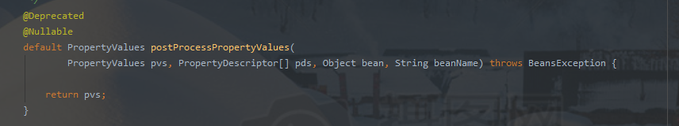

# 注解

## ComponentScanAnnotationParser

扫描@Component

# 属性

## spring.profiles.default

查看org.springframework.core.env.AbstractEnvironment文件

比如application-default.yml，指定其他，变为application-test.yml

# bean注册

## registerSingleton

一开始都没初始化

registerSingleton(String beanName, Object singletonObject)

### DefaultListableBeanFactory

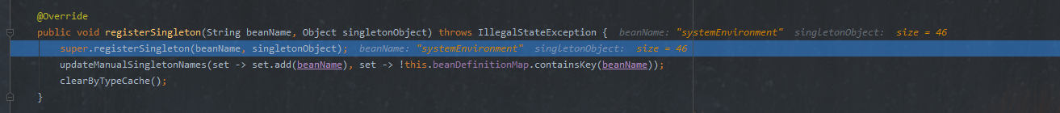

### DefaultSingletonBeanRegistry

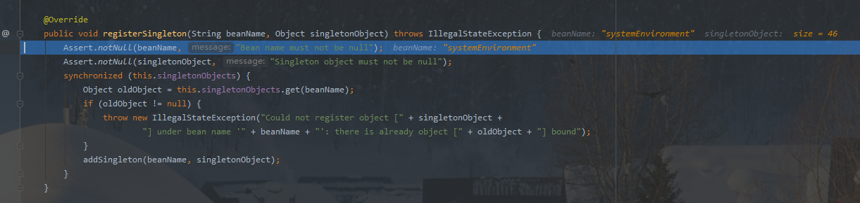

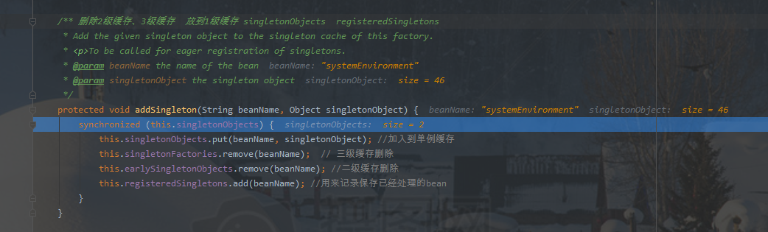

### DefaultListableBeanFactory

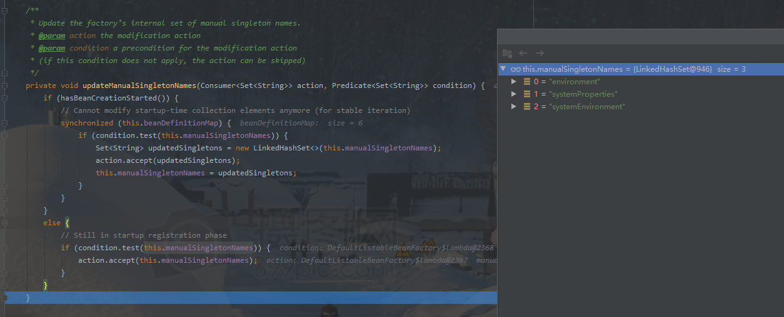

## getSingleton

